AWS RDS LAB 2

Creating an aurora database - step by step guide to create an aurora database

Step1 : login to aws account and navigate to RDS console.

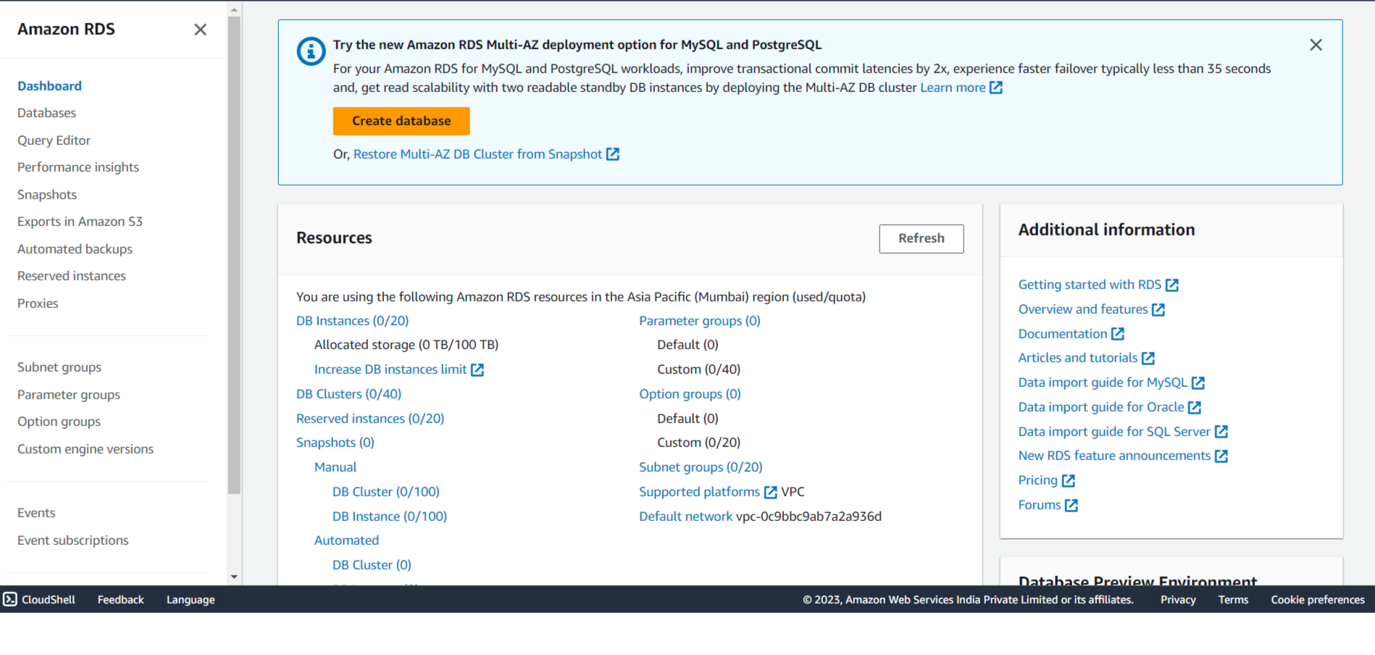

Step 2: Click on “create Database”

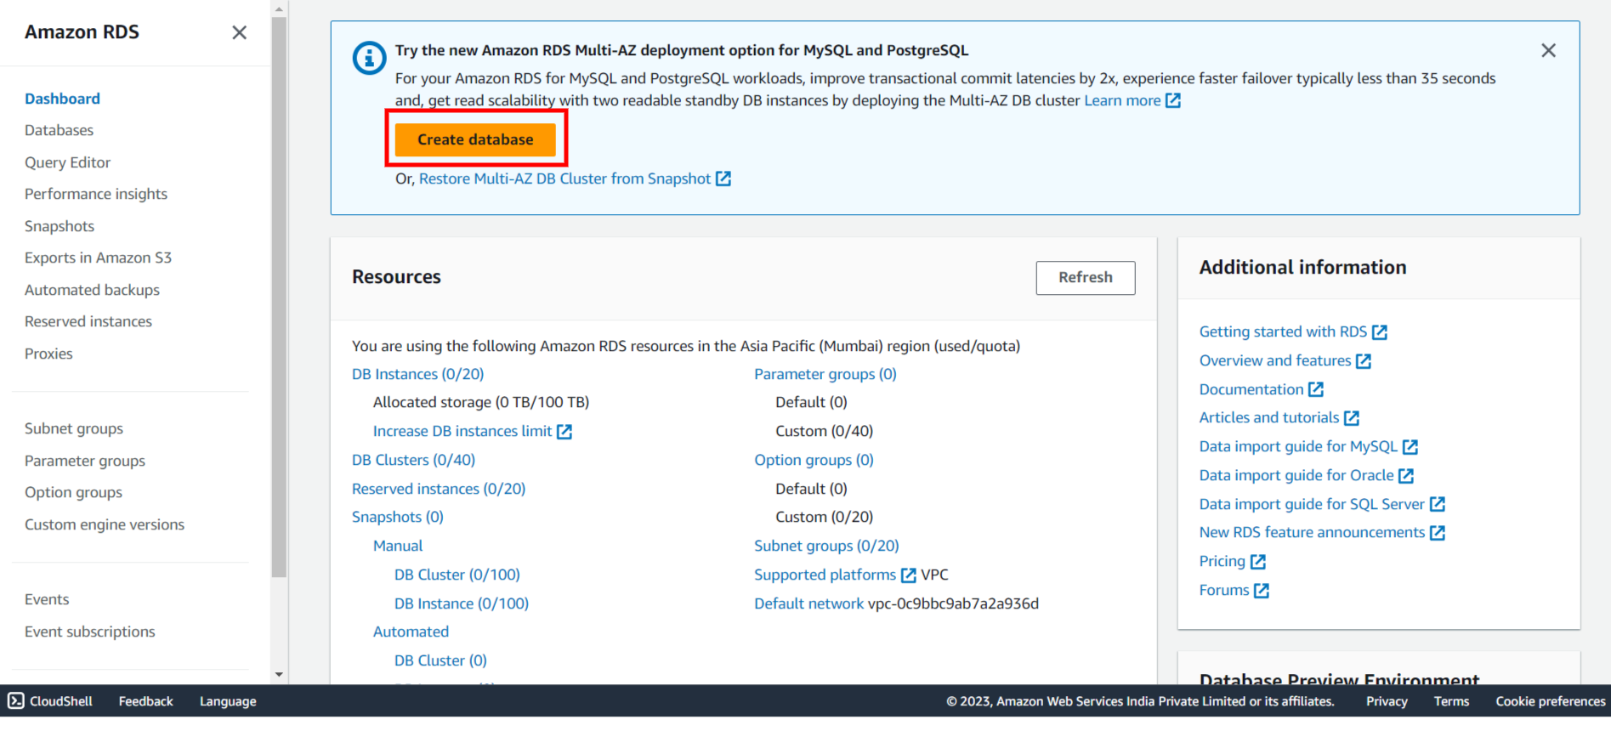

Step 3: To create a database,select the database creation method and engine type as “Aurora” database.

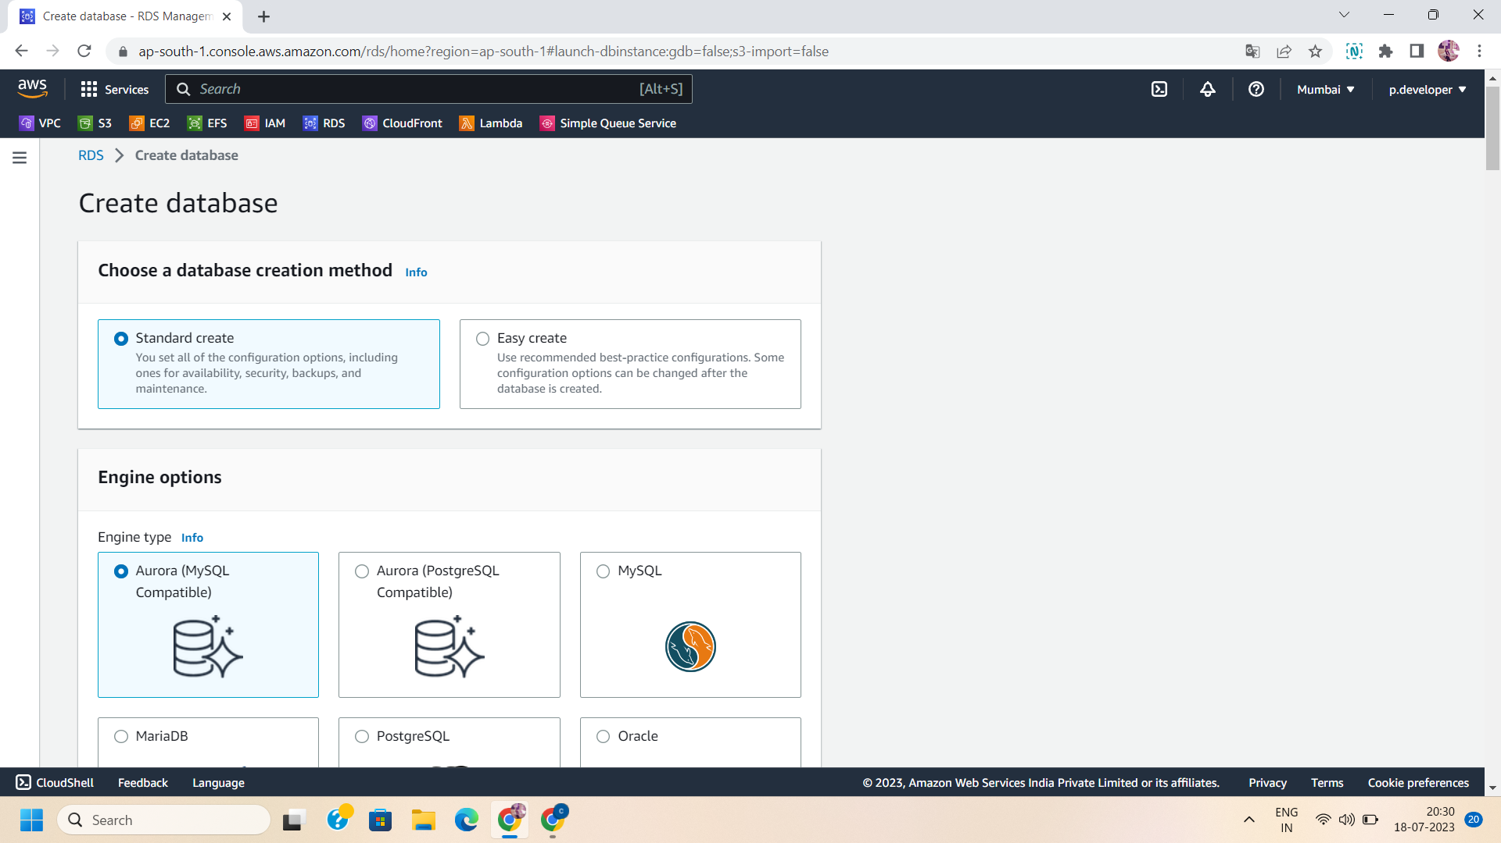

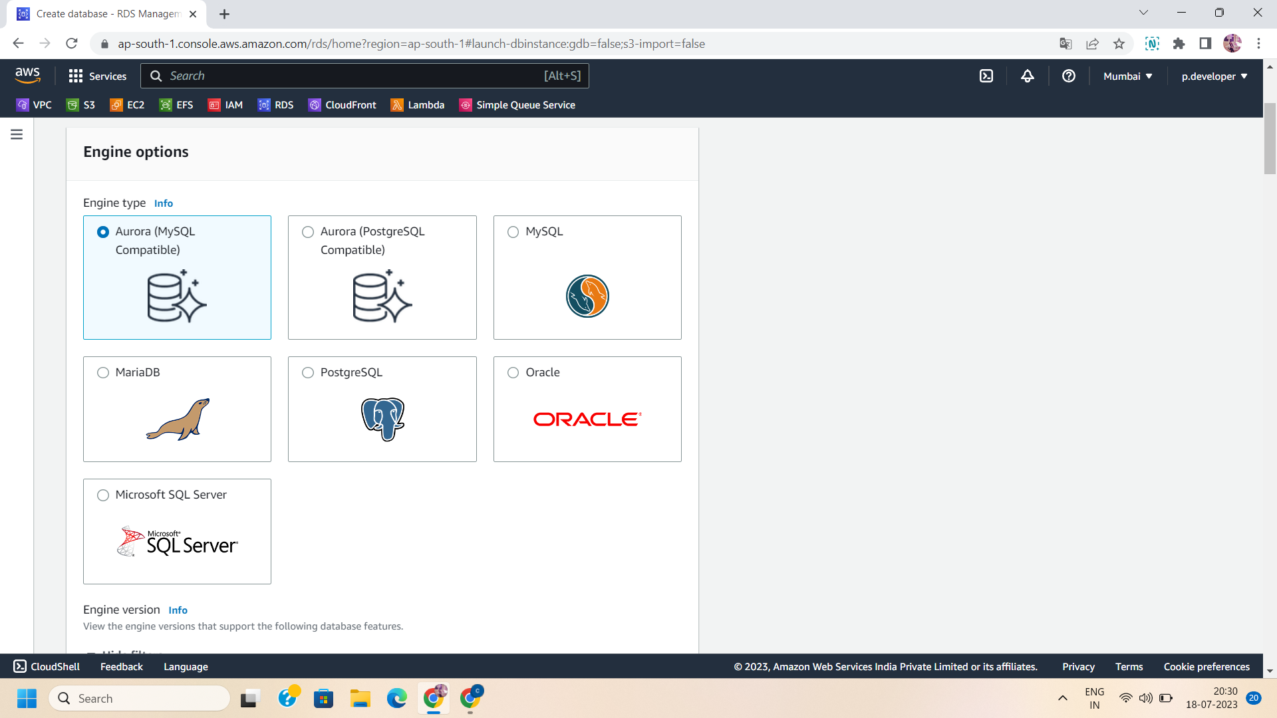

Step 4: Select the sample template.e., production or dev/test template and give a unique name to your database.

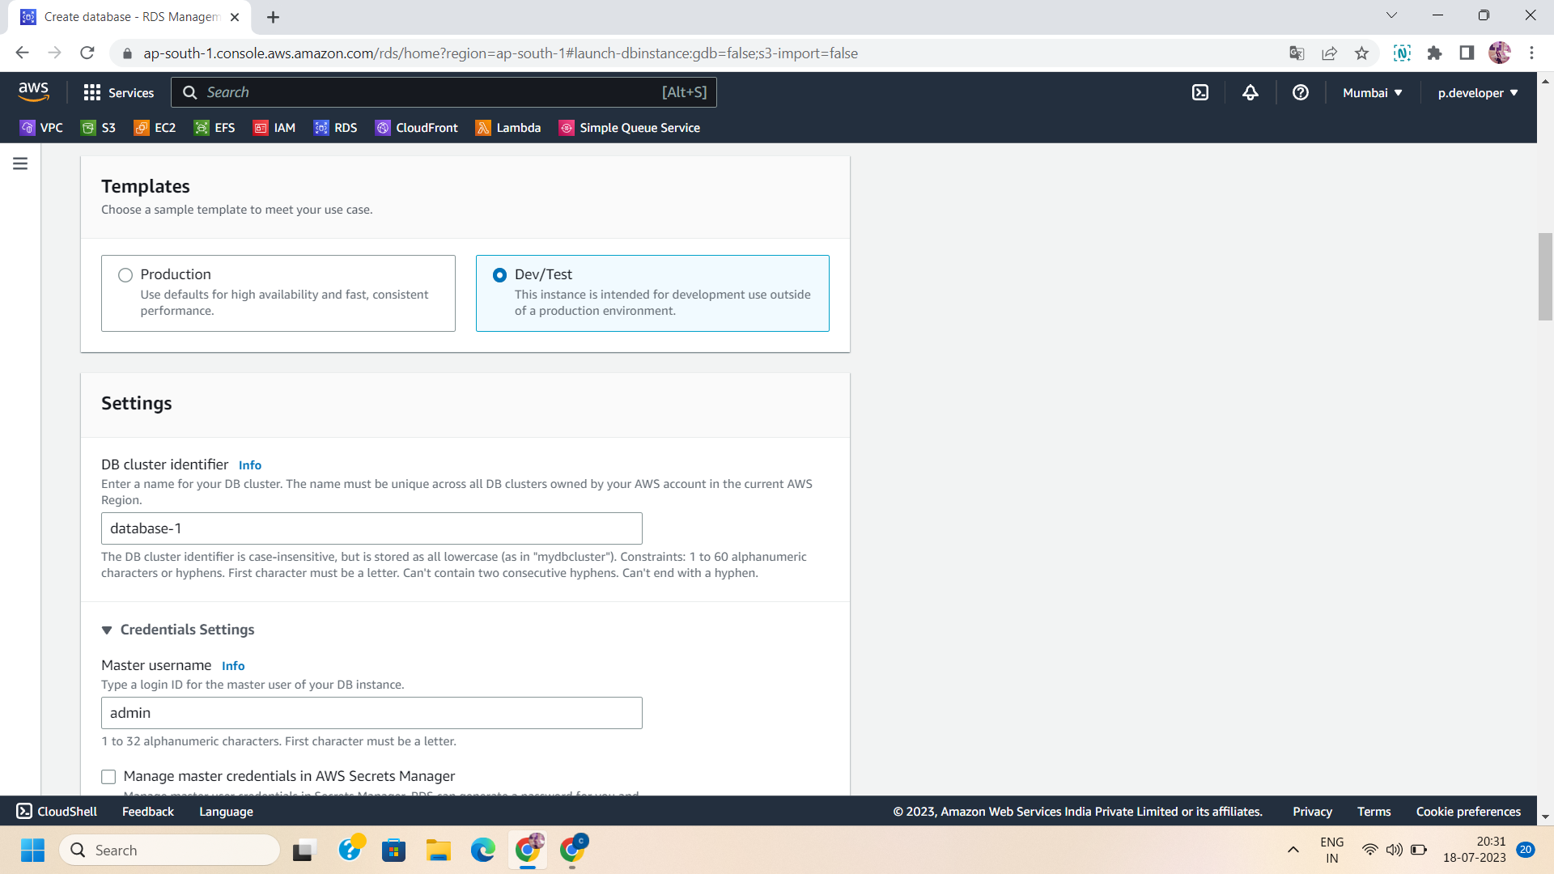

Step 5:Manage the cluster storage configurations:Aurora standard or Aurora I/O optimized.

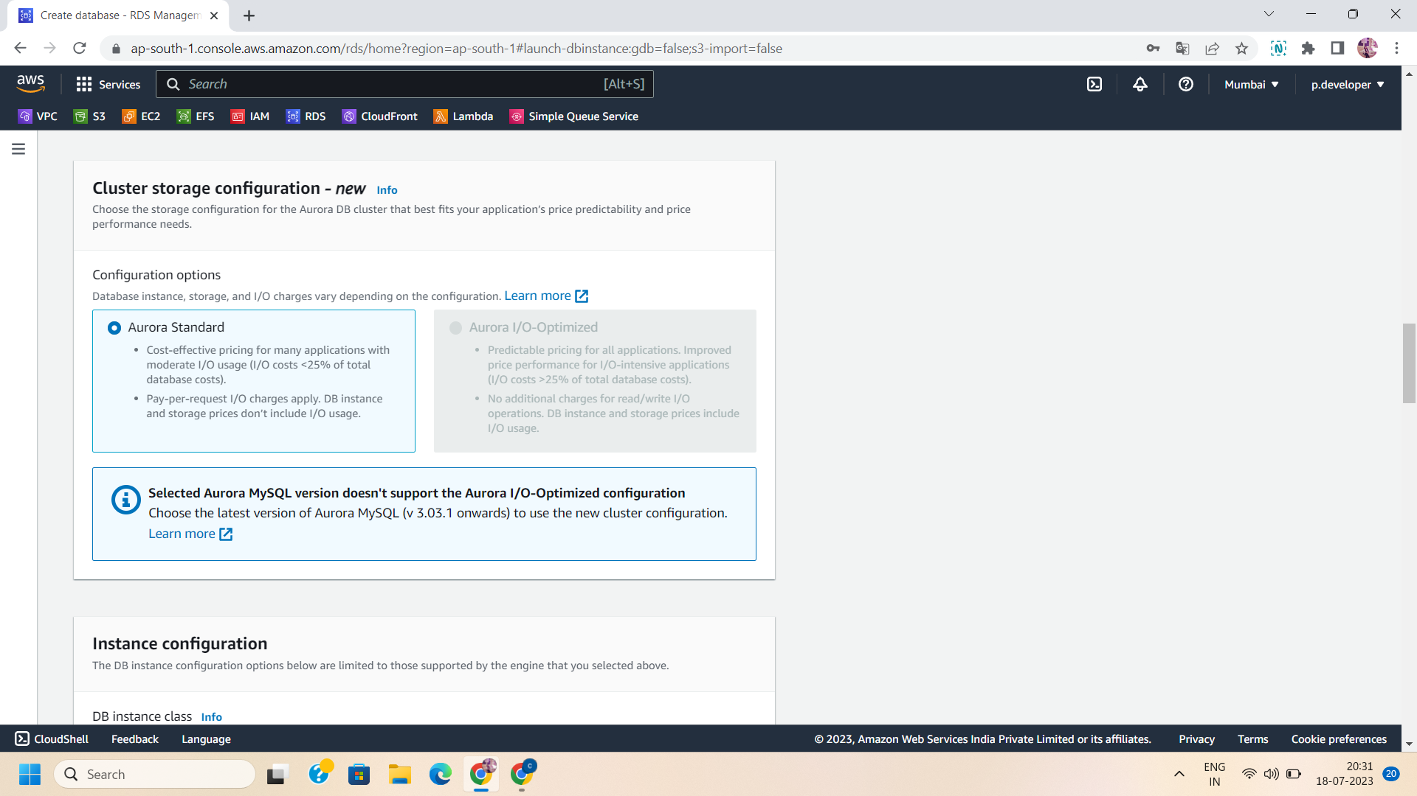

Step 6: Manage the Instance Configuration:

Select the instance class and multiple-az deployment settings of your database.

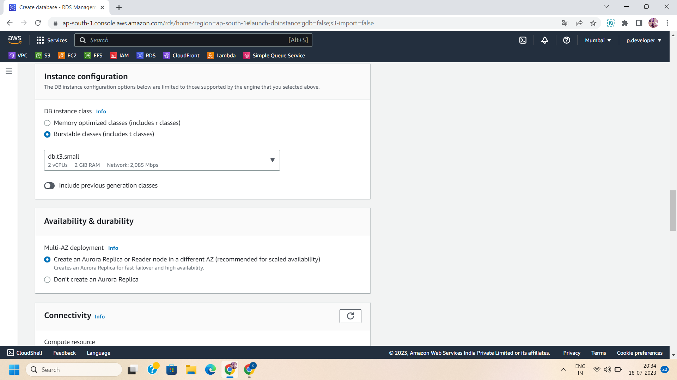

Step 7 : Select the instance or VPC ,you want to connect to your database

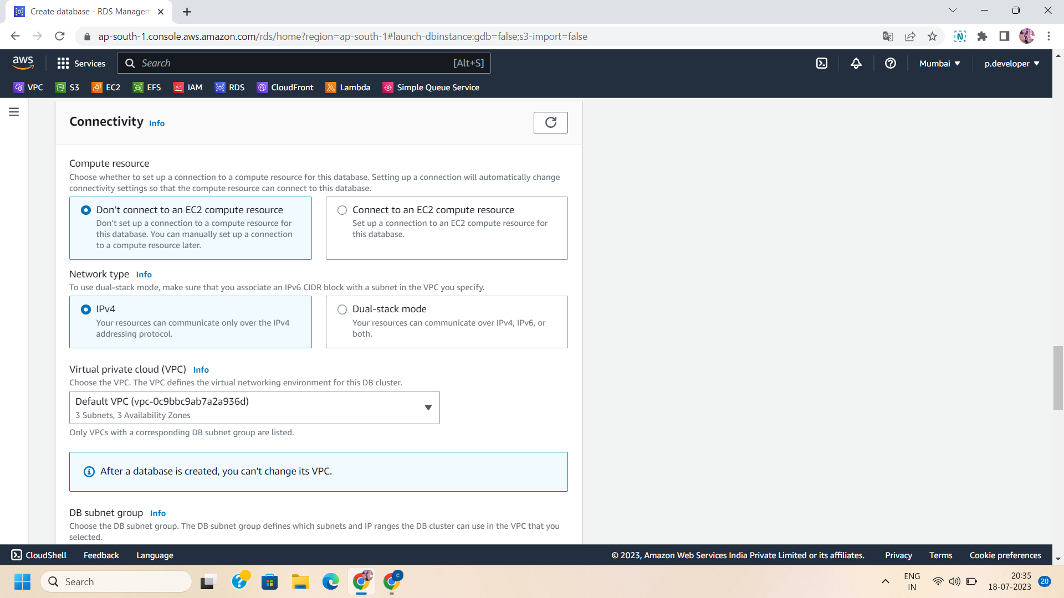

Step 8: Select the public level access permission and existing or create a new security group .

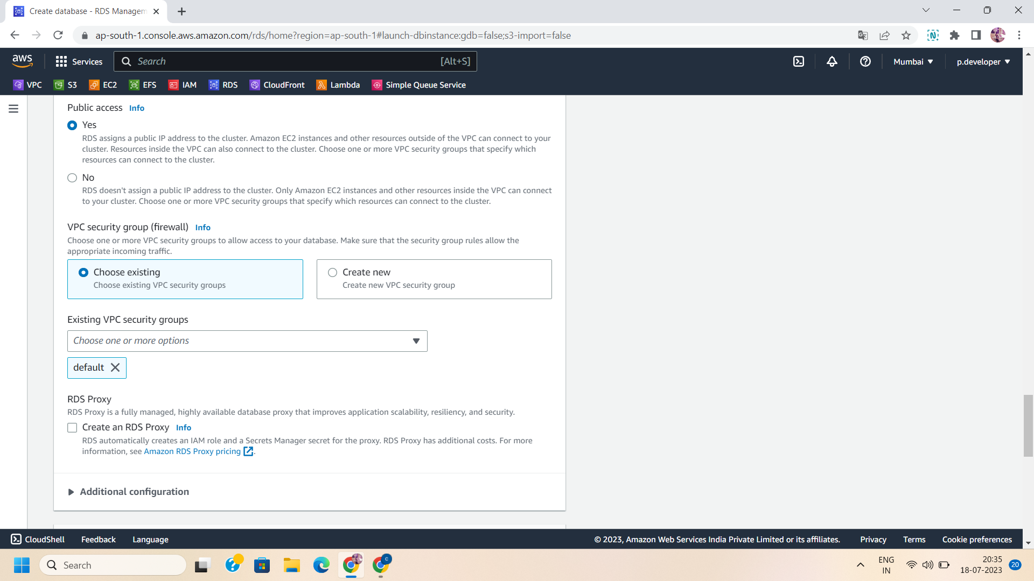

Step 9: Configure additional settings:

Give the initial database name and choose parameter and option groups.Define backup retention period, enable encryption and choose AWS KMS key to your database.

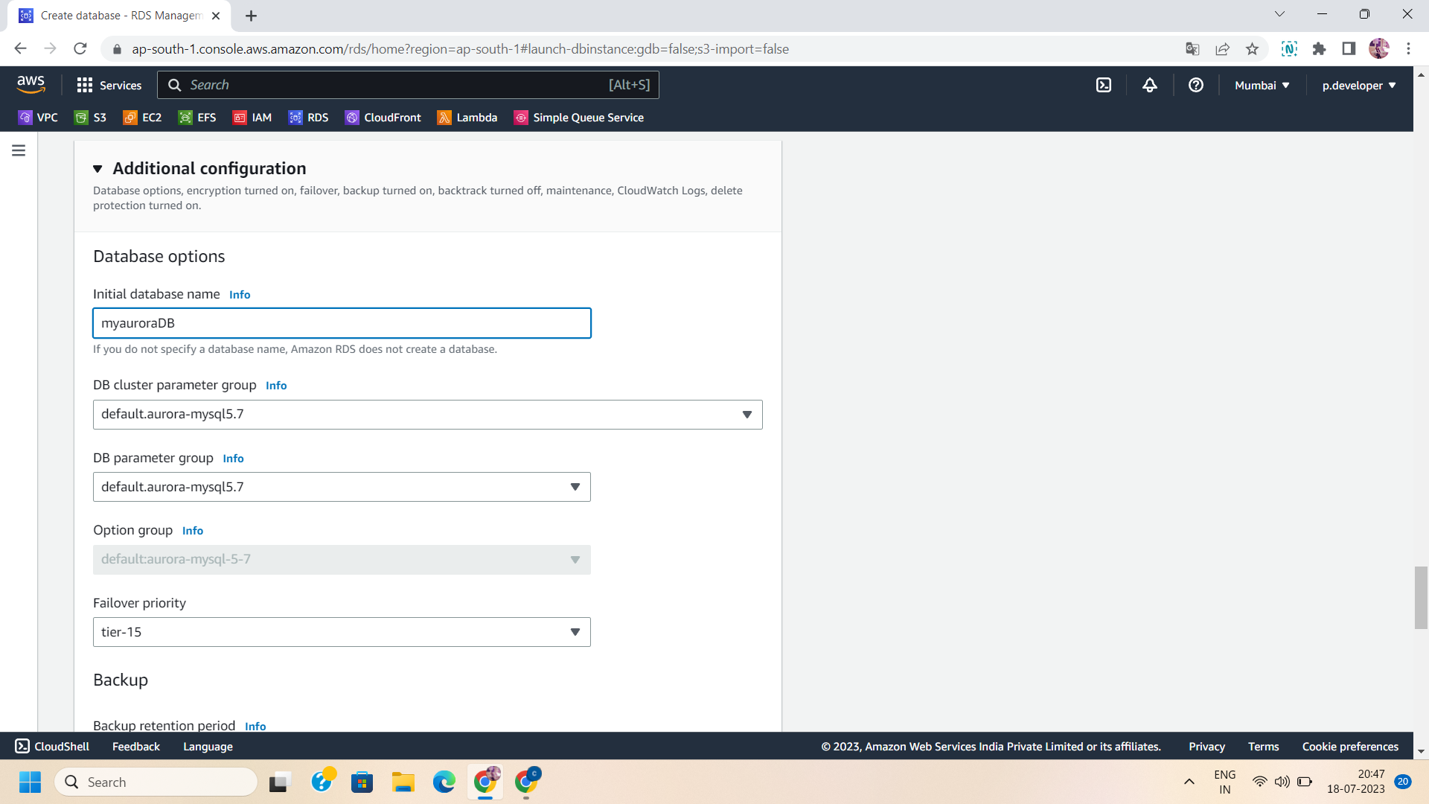

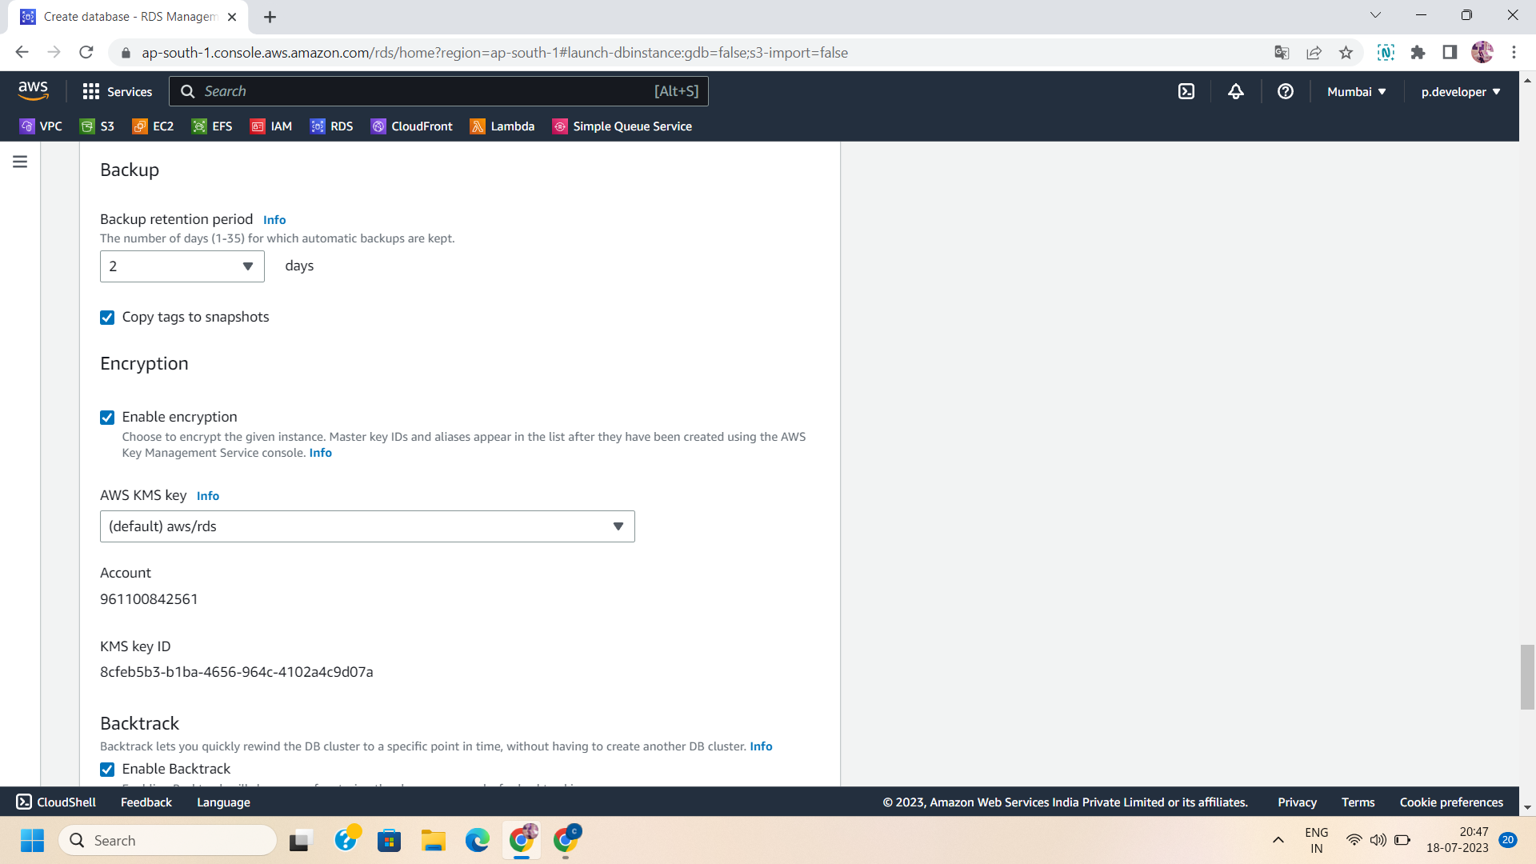

Step 10: Enable backtrack and check out log exports for your database. Configure the maintenance settings and delete on protection permissions.

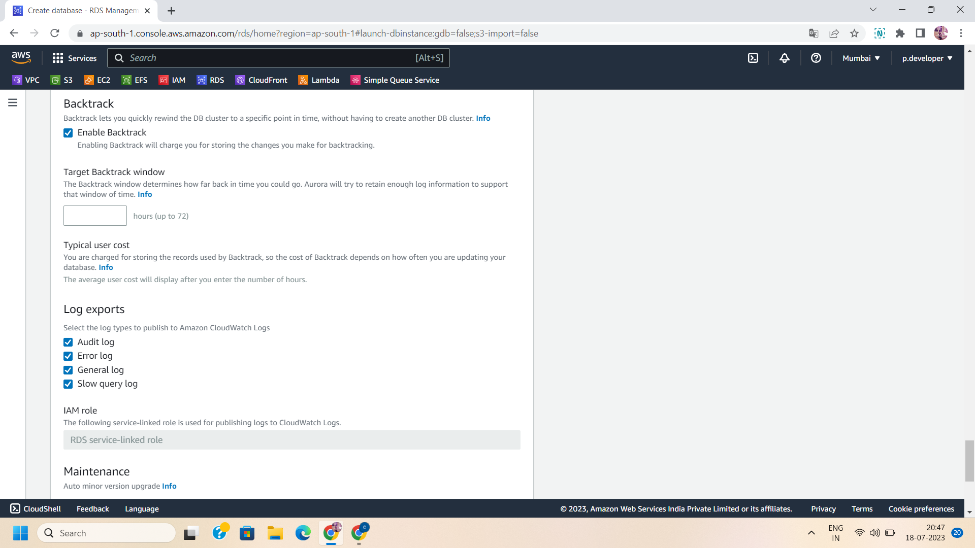

. 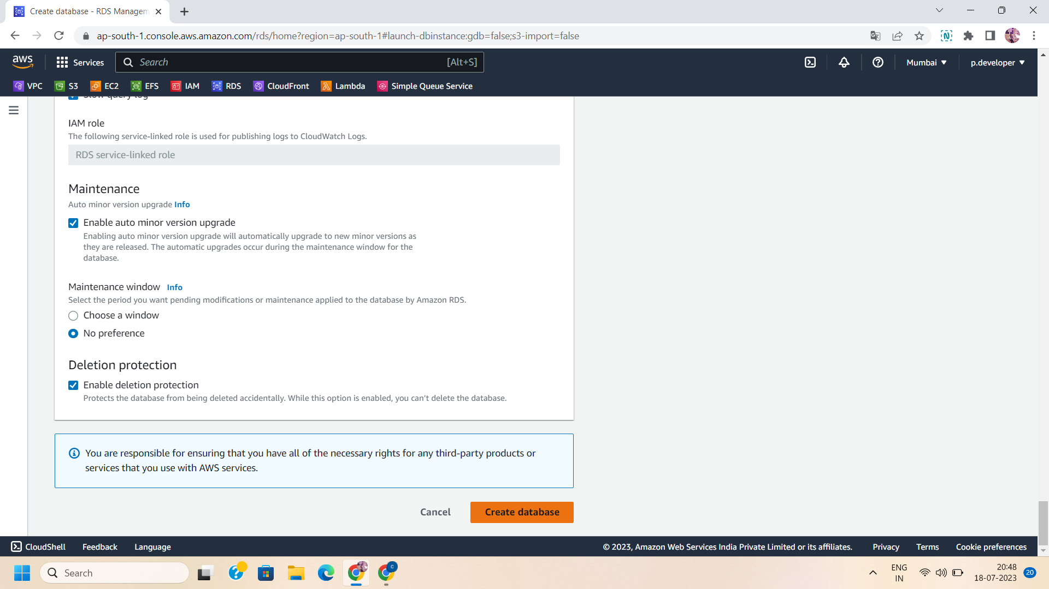

Step 11: After monitoring and additional configurations,click on” create database” to create the database for your aurora database.

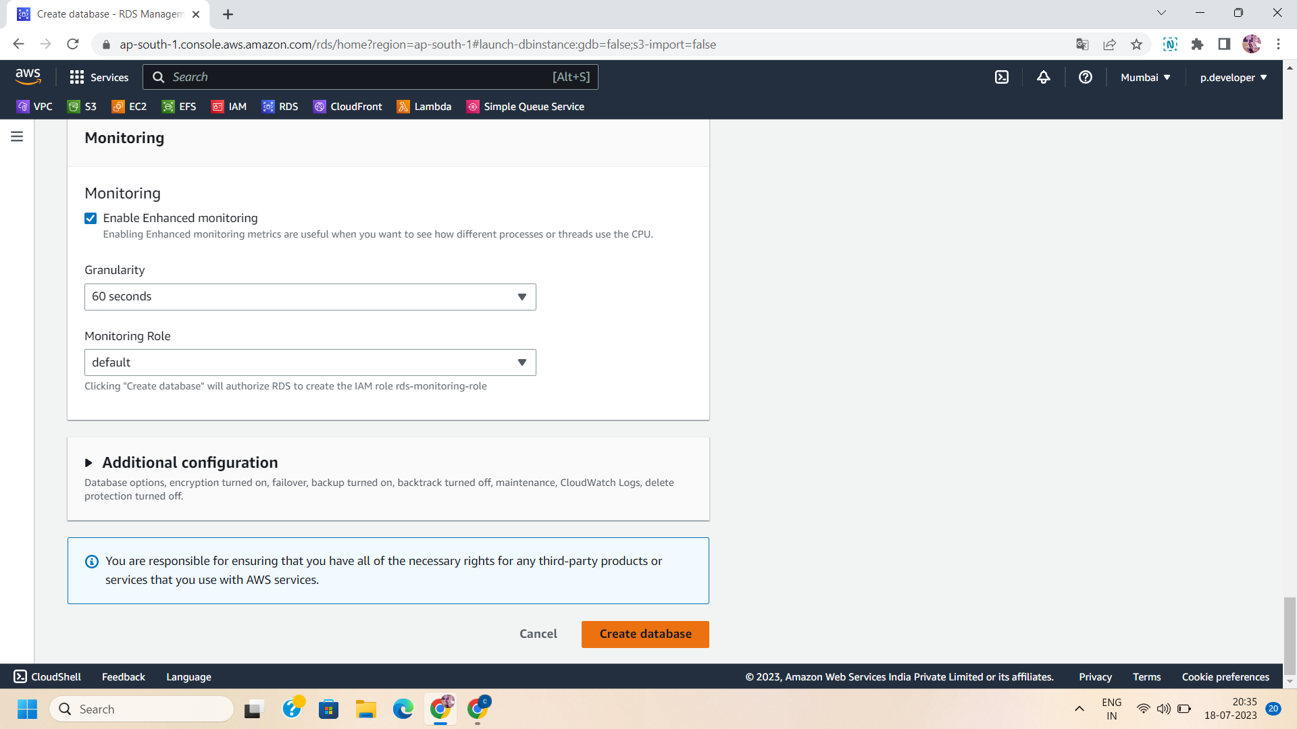

Step 12: Now,your aurora database is ready to implement various queries.

